Linux Privilege Audit — Findings Report
Name: Nandini das
Domain: Cybersecurity
Start date and End date: 15th September – 15th October

1. Project Overview
This project is a read-only Linux auditing toolkit written in Python. It checks selected system settings related to privilege escalation risks and reports evidence for human review. It does not attempt to exploit findings or modify system settings.
2. Project Objectives
- Automate selected Linux security checks.
- Help students learn practical system enumeration in an authorized lab.
- Provide evidence that defenders can review.
- Suggest mitigation or follow-up actions for reported indicators.
- Keep the toolkit detection-only.
3. Scope and Limitations
The current scanner checks host information, visible sudo policy, selected SUID/SGID files, selected cron paths, and file capabilities.
The scanner checks only selected locations. The sudo policy check may be incomplete if authentication is required. Findings are indicators for review, not confirmed vulnerabilities. A clean result does not prove that the entire system is secure.
4. Testing Environment and Method
Environment: [Linux distribution/version and VM, if applicable]
Scanner run as: nandini
Command used: python3 audit.py
Method: The scanner was run in an authorized lab environment. Its output was saved for review. No system settings were changed.
5. Findings
5.1 Sudo Policy
Status: Incomplete
Evidence: sudo: a password is required
Assessment: The scanner could not list the current user’s sudo policy without authentication. This does not mean that no sudo rules exist.
Suggested action: Ask an authorized administrator to review the user’s sudo policy.
5.2 File Capabilities
Status: Needs administrator validation
Evidence:
- /usr/bin/dumpcap — cap_net_admin, cap_net_raw
- /usr/bin/fping — cap_net_raw
Assessment: The scanner reported capabilities assigned to these files. This output alone does not confirm a vulnerability.
Suggested action: Have an administrator verify whether the capabilities are expected for the installed packages and system policy.
5.3 SUID/SGID Files
Status: Needs administrator validation
Evidence:
- /bin/kismet_cap_hak5_wifi_coconut — mode 004754, owner ID 0, group ID 103
- /bin/gpasswd — mode 004755, owner ID 0, group ID 0
- /bin/ssh-agent — mode 002755, owner ID 0, group ID 986
Assessment: The scanner found SUID/SGID permission bits. Their presence alone does not prove a vulnerability.
Suggested action: Have an administrator verify package ownership and expected permissions. Do not change permissions without authorization.
5.4 Selected Cron Paths
Status: No matching paths reported
Evidence: Scanner output: []
Assessment: None of the selected paths matched this check’s group/everyone-write condition.
Limitation: This was not a complete scan of every cron file or scheduled task.
6. Overall Assessment
The scan collected several items for review. The sudo policy check was incomplete because authentication was required. No selected cron path matched the scanner’s group/everyone-write condition. File capability and SUID/SGID entries require administrator validation. This scan did not confirm any exploitable vulnerability.
7. Mitigation and Follow-Up
- Ask an authorized administrator to verify whether the reported capabilities and SUID/SGID permissions are expected.
- Review sudo policy through the approved administrative process.
- Check package ownership and system documentation before recommending permission changes.
- Apply changes only after validation and approval.
- Do not treat an empty result from selected paths as proof that the entire system is secure.
8. Practical Testing Evidence
Environment: Linux virtual machine
Command used: python3 audit.py
Output file: scan-output.txt
The scanner was run in an authorized lab environment. It performed read-only checks and did not change system settings.
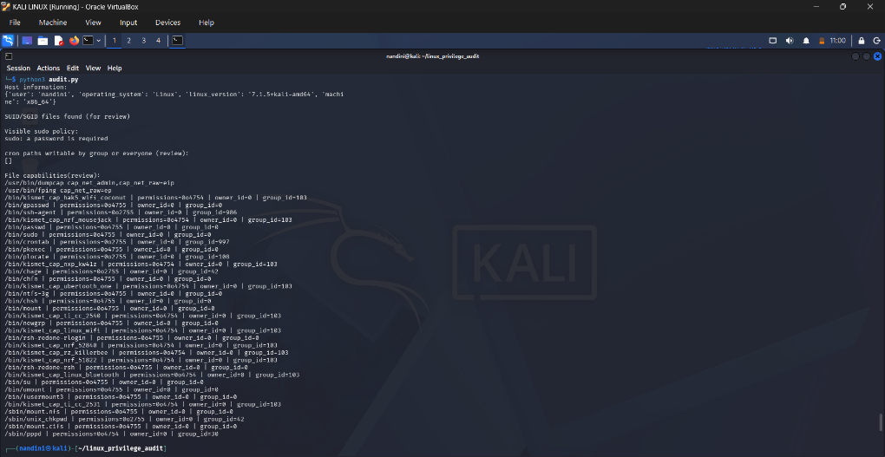
Figure 1: Scanner execution and selected check results from the Linux lab.
9. Limitations
The scanner checks selected locations and does not inspect every file or configuration on the system. The sudo policy check may be incomplete when authentication is required. The file-capabilities check depends on the availability of getcap. SUID/SGID files and capabilities can be legitimate system configuration.
The current version does not test exploitability, scan remote systems, or check kernel CVEs. A clean result does not prove that the system is secure.
10. Conclusion and Future Work
This project demonstrates how Python can automate selected, read-only Linux security checks and collect evidence for review. The results need human validation and should not be treated as confirmed vulnerabilities.
Future improvements could include broader test coverage, structured JSON reports, tests across different Linux distributions, and a carefully validated kernel advisory check.

